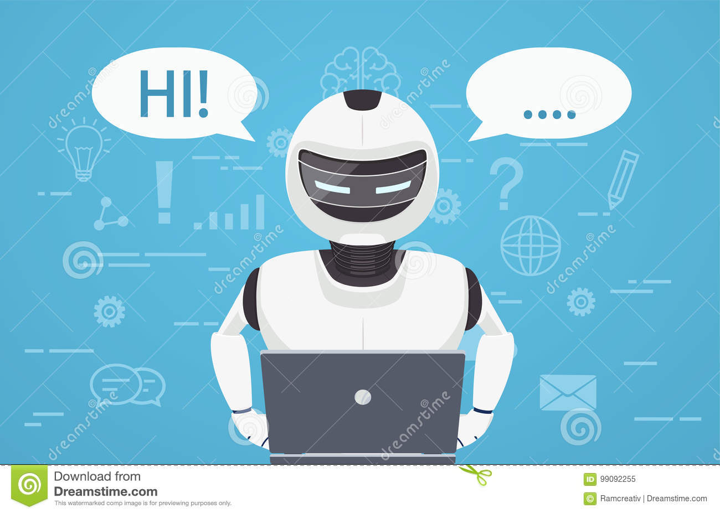

**Mini Project Report**

On

Virtual Computer Assistant

Thermo



**Submitted by:**

Manas Baranwal

(1901320310047)

**Submitted to:**

Mr. Sunil Kumar Yadav

**Objective**

As per the schedule of the course of B. Tech, AKTU Lucknow have made compulsory subject for Mini Project. The project work is a must for each and every student in CSE 2nd Year. During the development period, the student has to develop mini program and implement it successfully.

I have done the same, I want to thanks the AKTU and Our College for providing us this opportunity. I have learned a lot during this process. I have applied the theory that I have learned in Python language and successfully implemented in this project.

Firstly, I want to thank My parents for everything. I also want to thank everyone who helps me in any way to complete this project.

Thank You to all of you with honours.

I am pleased to submit this report on the project developed at Greater Noida Institute of Technology & Management as a part of 3rd-semester curriculums.

Once you login to the system, you can use all the task provided by this Virtual Assistant with your voice commands.

It reduces the time for the user to work on his/her system.

This project report contains an overview of the project.

The person with technical knowledge about programming and the Python language can easily understand the contents of this project.

**Methadology**

**Project Title:**

**Thermo (Virtual computer assistant)**

Computer Assistant, as by name Assistant means it is to assist someone. Computer assistant are created to assist user in technical problems virtually.

So, I have created a Virtual Computer Assistant “Thermo” which perform tasks by replacing the efforts of the user. The user has to operate this assistant with its voice.

As for my knowledge all the popular computer assistant available in the market do use internet to perform even their single task.

So, I am developing an assistant which can perform task (which do not require internet) offline.

“THERMO” can automatically check wheatear your device is connected through internet or not.

Although it cannot work as a proper assistant for now but I am working on it to add as many features as I can to make “THERMO” a good assistant.

**Design**

The language I used to create this assistant is PYTHON. Due to its rich libraries the creation of this project was much easier.

Libraries I used in my project are:

* *Pyttsx3*
* *Pyaudio*
* *Speech recognition*
* *Pocket sphinx*
* *Os*
* *Web Browser*
* *Wikipedia*
* *Pyautogui*
* *Wolframalpha*
* *Google*
* *Datetime*
* *Time, etc*

**Screenshots –**

First Look

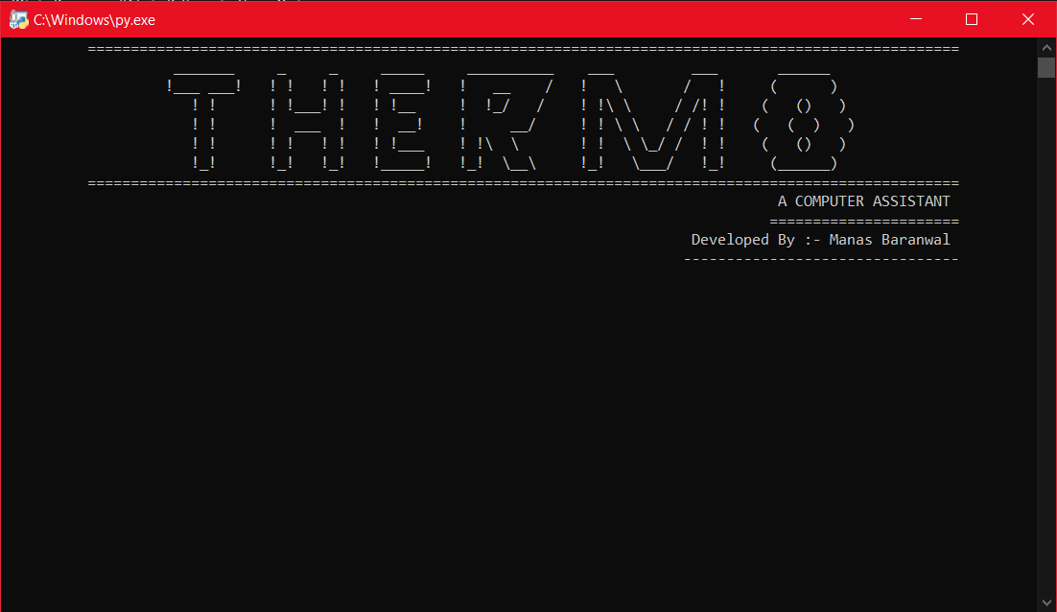

Online Mode

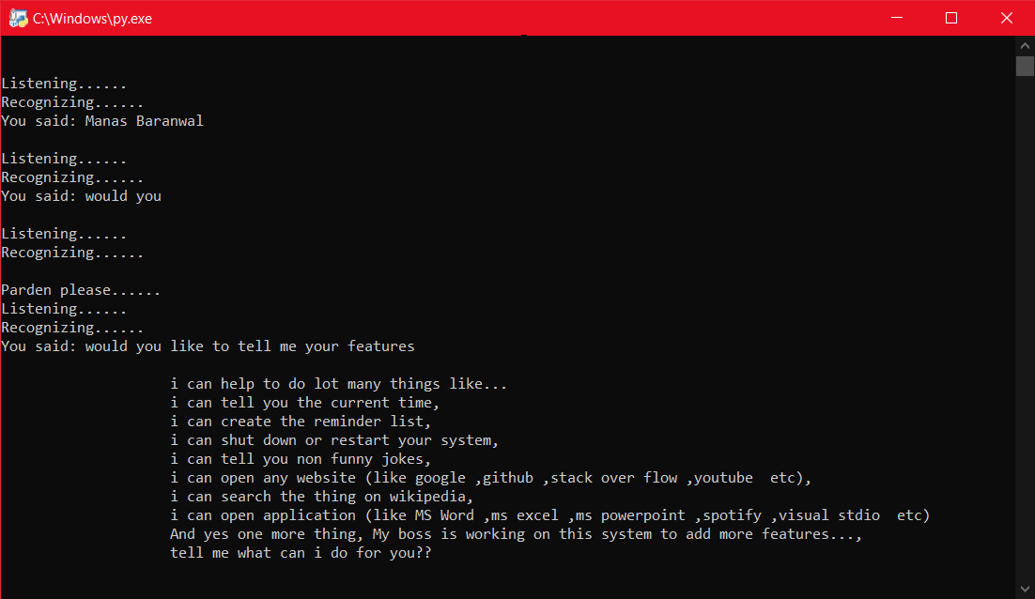

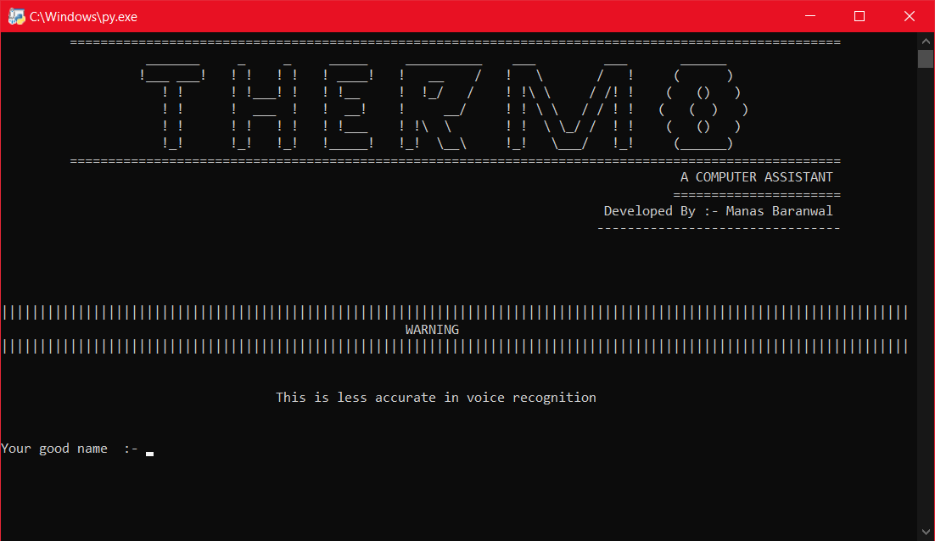 Offline Mode

To make this assistant work offline I spend a lot of time at its language module because the module I used to make THERMO listen the voice commands offline has only American English module. Finally, it can understand the Indian English but it is less accurate.

A lot of people will argue that the virtual assistant that I have created is not an Artificial Intelligence, but it is the output of the bunch of the statements. But, if we look at the very basic level, the sole purpose of an Artificial Intelligence Is to develop machines that can perform human tasks with the same effectiveness or even more effectively than humans.

It is a fact that this virtual assistant is not a very good example of Artificial Intelligence, **but it is an Artificial Intelligence.**

**Result**

The Virtual Assistant “THERMO” I have created performs as I thought of.

When in Online Mode:

THERMO can perform task like

* It can open Websites.
* It can search on Wikipedia.
* It can tell you non funny jokes.
* It can search anything on google.
* It can answer to computational and geographical questions.
* It can take screenshots and automatically save the picture.

And

* All the I have made to perform in offline mode can be done. So on.

When in Offline Mode:

THERMO can perform task like

* It can open application installed in system.
* It can save reminders.
* It can provide you current time and date.
* It can shutdown and restart your system.

Further task will be added in future development.

**Conclusion**

Practical Training is a very important part of the curriculum as it strengthens the concepts and enhances knowledge about the practical implementation of all the theory concepts, we have learned so far in different subjects.

My project will help many people whose work is to work on a computer system. This will provide the user with a new interface to connect with their system. They can perform their task with less effort.

Basically, this will assist everyone who work on the computer.

Although the project work has been done in a complete detailed manner but due to the short period of time, I could not include more features I wanted to. I left those features as a part of the future development. As soon as I will get time, I will try to add them to my project and make this assistant more friendly and better

**Future Scope**

Currently, there are several different companies developing virtual assistant technology, each targeting their own devices and hardware. For example, Microsoft’s Cortana works best with Windows 10 devices, Amazon’s Alexa works best with Amazon Devices, and Google Home uses its own platform.

More over in future these are going to be a part of our daily life.

So, the future scope of my virtual assistant “THERMO” will be bright by the requirement it fulfil for the user who will be using it.

It has to be more user friendly and perform more task in future. And I would love to make this assistant to capable in all the electronic devices in future.

